Submitted to:

Signature:

……………………………….

Submitted by:

Class: 11 ‘F’

Roll no. :

**Objective of This Project**

The objective of this computer project is to develop a software application that streamlines the process of managing student data for small businesses. The software will allow users to easily input their data for sign in, and they can also login using previous data There is a page for sign-in for new users in the pictures below, and there is a homepage where you can see the search bar and a text box to write your thoughts about the classes that you are taking. From there, you could go to the notifications page for notifications of online classes and the online class page, where you could see different subject classes at different times. There is also a page for assignments given to the students after the class is finished. You could submit the assignment given and also know the next assignment or previous assignment from the assignment page. There is also a page for results after the weekly test is done, which will show the growth of the students participating in the weekly test. This page will be updated further because it is only in development . Additionally, the application will feature tools for analyzing student data regarding their growth in the subject they are studying and the results as well. The goal is to provide students with a user friendly and efficient online class platform for doubt solving and ultimately improving their ability to make effective decisions and grow. To achieve this objective, the software will be designed with a simple and intuitive interface, utilizing modern design principles and best practices in user experience. The project will also prioritize security measures to protect sensitive customer information. Overall, the objective is to create a valuable tool that helps students better understand and solve their doubts in an increasingly competitive market. This project is made as simple as possible for easy use by students, and we also have some pictures regarding this project, which you can look at on other pages:

**Login and Sign Up form**

1. **Outer Page  (index.html)**

<!DOCTYPE html>

<html lang="en">

<head>

<meta charset="UTF-8">

<meta http-equiv="X-UA-Compatible" content="IE=edge">

<meta name="viewport" content="width=device-width, initial-scale=1.0">

<link rel="shortcut icon" href="favicon.ico" type="image/x-icon">

<title>Log in Or Signup</title>

<style>

     *{

         font-family: sans-serif;

         font-size: 25px;

     }

     body{

         background-image: url(background.jpg);

         z-index: -1;

     }

div.container{

         margin: 30%;

         margin-top: 200px;

         margin-bottom: 20px;

         border: 1px solid black;

         box-sizing: border-box;

         border-radius: 20px;

         min-height: 240px;

         width: 30%;

         box-shadow: 7px 7px 3px black,5px 5px 6px black;

         background-color: whitesmoke;

     }

     div.header{

         padding: 30px;

     }

     div.button{

         text-decoration: none;

         background-color: indianred;

         line-height: 50px;

         color: white;

         padding: 5px 0px;

     }

     a{

         text-decoration: none;

         color: white;

         padding-left: 15px;

         padding-top: 10px;

         padding-bottom: 10px;

padding-right: 0px;

text-shadow: 0px 0px 5px red, 0px 0px 8px  green;

background-color: salmon;

border-radius: 20px;

}

a:hover{

background-color: aqua;

text-shadow: 0px 0px 5px red,0px 0px 8px tomato;

}

h1{

text-align: center;

background-color: lightgoldenrodyellow;

padding: 7px 0px;

color: deepskyblue;

text-shadow: 0px 0px 3px palevioletred;

border: 2px dotted burlywood;

}

p{

text-shadow: 0px 0px 3px goldenrod,0px 0px    4px cyan;

}

.human{

         position: absolute;

         text-align: center;

         background-color: lightgrey;

         color: red;

         left: 540px;

         padding: 13px;

         text-shadow: 0px 0px 2px darkred;

         border-radius: 5px;

         box-shadow: 4px 4px 4px 2px black;

         z-index: 3;

         }

     .checkbox{

         width: 20px;

         height: 20px;

         cursor: pointer;

     }

</style>

</head>

<body>

<div class="container">

     <div class="header">

     <h1>Log In or Sign Up form!</h1>

     <p>New member to this site..<br>

Click on Sign-Up</p>

     </div><hr>

<div class="button">

     <a href="login.html" class="login">Log-In&nbsp;&nbsp;</a>&nbsp;&nbsp;&nbsp;&nbsp;&nbsp;&nbsp;&nbsp;

         <a href="signup.html" class="signup">Sign-Up&nbsp;&nbsp;</a>

     </div>

</div>

<div class="human">

     <input type="checkbox" class="checkbox" required>&nbsp;&nbsp;Are You Human?

</div>

</body>

</html>

This is an HTML document that creates a login and sign-up page with a background image and some styling. The document contains a div container with a header and two a tags that link to login and signup pages respectively. The div also contains a checkbox input to verify if the user is human or not.

The style section of the document defines the styling for various elements of the page, such as font family, font size, background color, border, padding, etc. The background.jpg image file is used as the background image for the page.

The h1 and p tags are used to create the heading and a short message respectively. The a tags are styled with text-decoration, background-color, padding, and border-radius properties to create buttons. The hover pseudo-class is used to change the background color and text shadow when the mouse hovers over the buttons.

The human class is used to create a div element that positions a checkbox input on the page with a message asking the user to verify if they are human. The checkbox input has a cursor property that changes the cursor to a pointer when the user hovers over it.

**2. Sign Up Page  (signup.html)**

<!DOCTYPE html>

<html lang="en">

<head>

<meta charset="UTF-8">

<meta http-equiv="X-UA-Compatible" content="IE=edge">

<meta name="viewport" content="width=device-width, initial-scale=1.0">

<title>Login</title>

<link rel="shortcut icon" href="signup.png" type="image/x-icon">

<style>

     body{

         background-color: lightgoldenrodyellow;

         min-height: 150vh;

     }

     .container{

         margin-top: 250px;

         margin-left: 350px;

         border: 2px solid red;

         outline: 1px solid orange;

         width: 50%;

         background-color: aliceblue;

         min-height: 500px;

         border-radius: 20px;

         position: relative;

     }

     h1{

         text-decoration: underline;

         text-align: center;

         color: white;

         text-shadow: 0px 0px 10px rgb(134, 219, 247),0px 0px 5px tomato;

     }

     #signup{

         padding-left: 20px;

         padding-bottom: 5px;

     }

     p{

         font-size: 20px;

         font-family: 'Segoe UI', Tahoma,Verdana, sans-serif;

         display: inline-block;

         color: rgb(250, 67, 35);

     }

     .text,.number{

         width: 95%;

         height: 25px;

         border-radius: 5px;

         padding: 8px 0px;

         padding-left: 30px;

         font-size: medium;

     }

     .submit{

         position: absolute;

         left: 450px;

         width: 10%;

         height: 40px;

         border-radius: 12px;

         background-color: coral;

         cursor: pointer;

         font-size: medium;

         color: white;

     }

     .checkbox{

         position: absolute;

         left: 670px;

         width: 10%;

         height: 20px;

         border-radius: 12px;

         background-color: coral;

         cursor: pointer;

         font-size: medium;

         color: white;

     }

     #checkbox{

         position: absolute;

         left: 700px;

         width: 15%;

         border:2px dotted red;

         border-radius: 12px;

         font-size: 18px;

         color: black;

         text-shadow: 0px 0px 1px blue;

         padding: 5px;

         background-color: antiquewhite;

     }

</style>

</head>

<body>

<div class="container">

     <h1>Sign-Up</h1><hr>

     <br><br>

     <form name="signup" id="signup">

     <p>First Name:</p><br>

     <input type="text" name="" class="text" id="fname" placeholder="Anurodh" required>

     <p>Last Name:</p><br>

     <input type="text" name="" class="text" id="lname" placeholder="Prasai" required>

     <p>Date OF Birth:</p><br>

     <input type="date" name="" class="number" id="DOB" required>

     <p>UserName:</p><br>

     <input type="email" name="" class="text" id="email" placeholder="someone@gmail.com">

     <p>Password:</p><br>

     <input type="password" name="" class="text" id="pass" placeholder="Create a strong Password">

</div>

<br>

     <input type="submit" value="Sign-In" class="submit" onclick="myfunction()"><br><br>

     <input type="checkbox" name="" class="checkbox"><br><p id="checkbox">I agree With all the terms and conditions</p>

</form>

</body>

<script>

function myfunction(){

     alert("You have succesively created a new account.");

}

</script>

</html>

This is an HTML document that contains a form for signing up with some input fields and a submit button. The form has the following fields:

* First name: An input field of type text with a placeholder "Anurodh" and an id "fname".
* Last name: An input field of type text with a placeholder "Prasai" and an id "lname".
* Date of birth: An input field of type date with an id "DOB".
* Username: An input field of type email with a placeholder "someone@gmail.com" and an id "email".
* Password: An input field of type password with a placeholder "Create a strong Password" and an id "pass".

There is also a checkbox with a label "I agree with all the terms and conditions". When the user clicks on the submit button, an alert message saying "You have successfully created a new account." will be displayed.

**3. Login Page  (login.html)**

<!DOCTYPE html>

<html lang="en">

<head>

<meta charset="UTF-8">

<meta http-equiv="X-UA-Compatible" content="IE=edge">

<meta name="viewport" content="width=device-width, initial-scale=1.0">

<title>Login</title>

<link rel="shortcut icon" href="log-in.png" type="image/x-icon">

<style>

     body{

         background-color: lightgoldenrodyellow;

     }

     .container{

         margin-top: 200px;

         margin-left: 350px;

         border: 2px solid red;

         outline: 1px solid orange;

         width: 40%;

         background-color: aliceblue;

         min-height: 200px;

         border-radius: 20px;

         position: relative;

     }

     h1{

         text-decoration: underline;

         text-align: center;

         color: white;

         text-shadow: 0px 0px 10px rgb(134, 219, 247),0px 0px 5px tomato;

     }

     #login{

         padding-left: 30px;

         padding-bottom: 20px;

     }

     p{

         font-size: 20px;

         font-family: 'Segoe UI', Tahoma,Verdana, sans-serif;

         display: inline-block;

         color: rgb(250, 67, 35);

     }

     .text,.number{

         width: 90%;

         height: 25px;

         border-radius: 5px;

         padding: 8px 0px;

         padding-left: 30px;

         font-size: medium;

     }

     .submit{

         position: absolute;

         left: 450px;

         width: 10%;

         height: 40px;

         border-radius: 12px;

         background-color: coral;

         cursor: pointer;

         font-size: medium;

         color: white;

     }

     .checkbox{

         position: absolute;

         left: 670px;

         width: 10%;

         height: 20px;

         border-radius: 12px;

         background-color: coral;

         cursor: pointer;

         font-size: medium;

         color: white;

     }

     #checkbox{

         position: absolute;

         left: 700px;

         width: 15%;

         border:2px dotted red;

         border-radius: 12px;

         font-size: 18px;

         color: black;

         text-shadow: 0px 0px 1px blue;

         padding: 5px;

         background-color: antiquewhite;

     }

</style>

</head>

<body>

<div class="container">

     <h1>Log-In</h1><hr>

     <form name="login" id="login" action="anotherpage.html">

     <p><b>UserName:</b></p><br>

     <input type="email" name="" class="text" id="email" placeholder="someone@gmail.com">

     <p><b>Password:</b></p><br>

     <input type="password" name="" class="text" id="pass" placeholder="******">

</div>

<br>

     <input type="submit" value="Sign-In" class="submit" onclick="myfunction()"><br><br>

</form>

</body>

<script>

function myfunction(){

     alert("You have logged In sucessfully");

}

</script>

</html>

This is an HTML code for a login page. The page contains a form with two input fields: one for the user's email address and one for their password. There is also a submit button that triggers an alert message when clicked. The page has some styling applied to it, including a background color, a border, and some font styles. The form's action attribute is set to "anotherpage.html", which means that the user will be redirected to another page after submitting the form.

**4. Logged in Page  (anotherpage.html)**

<!DOCTYPE html>

<html lang="en">

<head>

<meta charset="UTF-8">

<meta http-equiv="X-UA-Compatible" content="IE=edge">

<meta name="viewport" content="width=device-width, initial-scale=1.0">

<title>Grade 11 Computer Science</title>

<link rel="shortcut icon" href="signup.png" type="image/x-icon">

<style>

     body{

         background-color: lightcyan;

     }

     .bar{

         width: 15%;

         border: 1px solid lightcyan;

         height: 100vh;

         background-color: rgb(228, 220, 220);

         position: fixed;

         overflow-y: scroll;

     }

     ul{

         list-style-type: none;

         font-size: large;

         padding: 0px;

         margin-top: 4px;

         position:absolute;

         top: -5px;

         width: 100%;

     }

     a{

         text-decoration: none;

         color: black;

     }

     li{

         background-color: whitesmoke;

         padding: 10px;

         padding-left: 30px;

         padding-top: 15px;

         padding-bottom: 15px;

         cursor: pointer;

     }

     li:nth-child(odd){

         background-color: rgb(196, 193, 193);

     }

     li:hover{

         font-weight: bold;

     }

     li.home{

         background-color: green;

         color: white;

         font-weight: bold;

     }

     .content{

         width: 70%;

         margin-left: 20%;

         border: 2px solid tomato;

         border-radius: 5px;

         padding: 5px 20px;

         height: 550px;

         background-color: skyblue;

     }

     .header{

         margin-top: 20px;

         padding: 15px;

         background-color: blue;

         color: antiquewhite;

         font-family: Arial, Helvetica, sans-serif;

         width: 25%;

         font-size: large;

         border-radius: 7px;

     }

     #textbox{

         padding: 100px;

         font-size: large;

         width: 70%;

         height: 100px;

         border-radius: 7px;

     }

     #sumit{

         background-color: red;

         padding: 10px;

         font-size: medium;

         color: white;

         cursor: pointer;

         border-radius: 7px;

     }

     .search{

         margin: 10px;

         background-image: url(search.png);

         background-position: 10px 3.4px;

         background-repeat: no-repeat;

         width: 8%;

         font-size: medium;

         transition: 0.7s ease-in-out;

         border: 2px solid grey;

         border-radius: 7px;

         padding: 20px 0px;

         padding-left: 75px;

     }

     .search:hover , .search:focus{

         width: 80%;

         border:2px solid red;

         resize: none;

     }

     .hidden{

         padding: 3px;

         font-size: 20px;

         color: tomato;

         display: none;

         z-index: 100;

         position: absolute;

     }

     .yes{

         padding: 10px;

         background-color: red;

         color: ghostwhite;

         display: inline-block;

     }

     div.abc:hover div.hidden{

         display: inline-block;

     }

     div.abc:active div.hidden{

         display: inline-block;

     }

     .abc{

         position: relative;

         display: inline-block;

         width: 100%;

     }

</style>

</head>

<body>

<div class="container">

     <div class="bar">

         <ul>

             <li class="home">Home</li>

             <li>Notifications</li>

             <li>Online Classes</li>

             <li>Assignments</li>

             <li>Results</li>

             <li>Class Routine</li>

             <li>About</li>

             <li>Help</li>

             <div class="abc">

             <li class="logout"><a href="#" class="out">Logout</a></li>

             <div class="hidden">

                 Are you sure you want to log out?<br>

                 &nbsp;&nbsp;&nbsp;&nbsp;<a href="login.html" class="yes" onclick="myfunction()">Yes</a>

             </div>

             </div>

         </ul>

     </div>

     <div class="content">

         <div class="header">WELCOME TO CLASS 11 'F'</div><br>

         <input type="text" placeholder="Search" class="search">

         <label><textarea name="" id="textbox" cols="30" rows="10" placeholder="Write your thoughs and views you want to share with your class"></textarea></label>

         <br><br>

         <input type="submit" value="Submit" id="sumit">

</div>

</div>

</body>

<script>

function myfunction(){

alert('!!   You have been logged out successfully   !!');

}

</script>

</html>

This is an HTML and CSS code for a webpage designed for Grade 11 Computer Science class.

The webpage has a fixed left navigation bar that takes 15% of the viewport width and has a light cyan background color. It contains an unordered list with list items representing different pages such as Home, Notifications, Online Classes, Assignments, Results, Class Routine, About, Help, and Logout.

The Home page is highlighted with a green background color and bold white text. The list items have a light gray and white alternating background color with a bold font on hover.

The content area takes 70% of the viewport width, and it's positioned 20% from the left. It has a sky blue background color with a 2px solid tomato red border with 5px border radius. It contains a header with a blue background color and white text with a 25% width and 7px border radius.

There is a search bar with a magnifying glass icon on the right side of the content area, and it has a gray border and a 7px border radius. When hovered or focused, the search bar expands to 80% width and has a red border.

The content area also has a textarea for the user to write their thoughts and views, with a 100px padding on all sides, a 7px border radius, and 70% width.

There is a submit button with a red background color, white text, and 7px border radius.

At the bottom of the list in the navigation bar, there is a logout link that displays a hidden div with a red background color and white text that asks the user if they are sure they want to log out. If the user clicks on the "Yes" link, it will redirect to the login page and display an alert message saying "You have been logged out successfully."

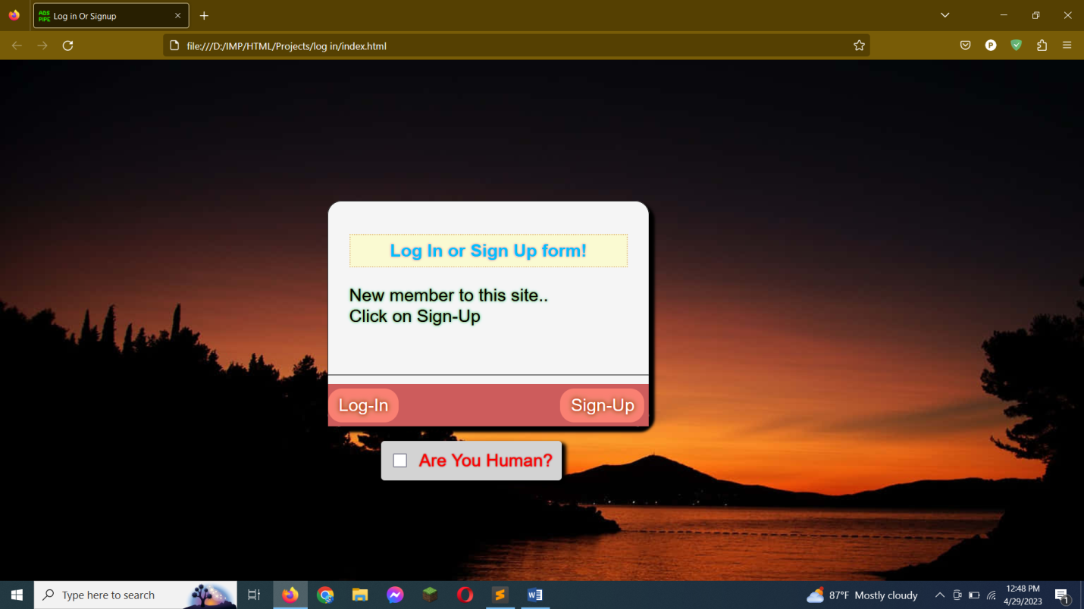

**Fig : Log in or sign up (index.html)**

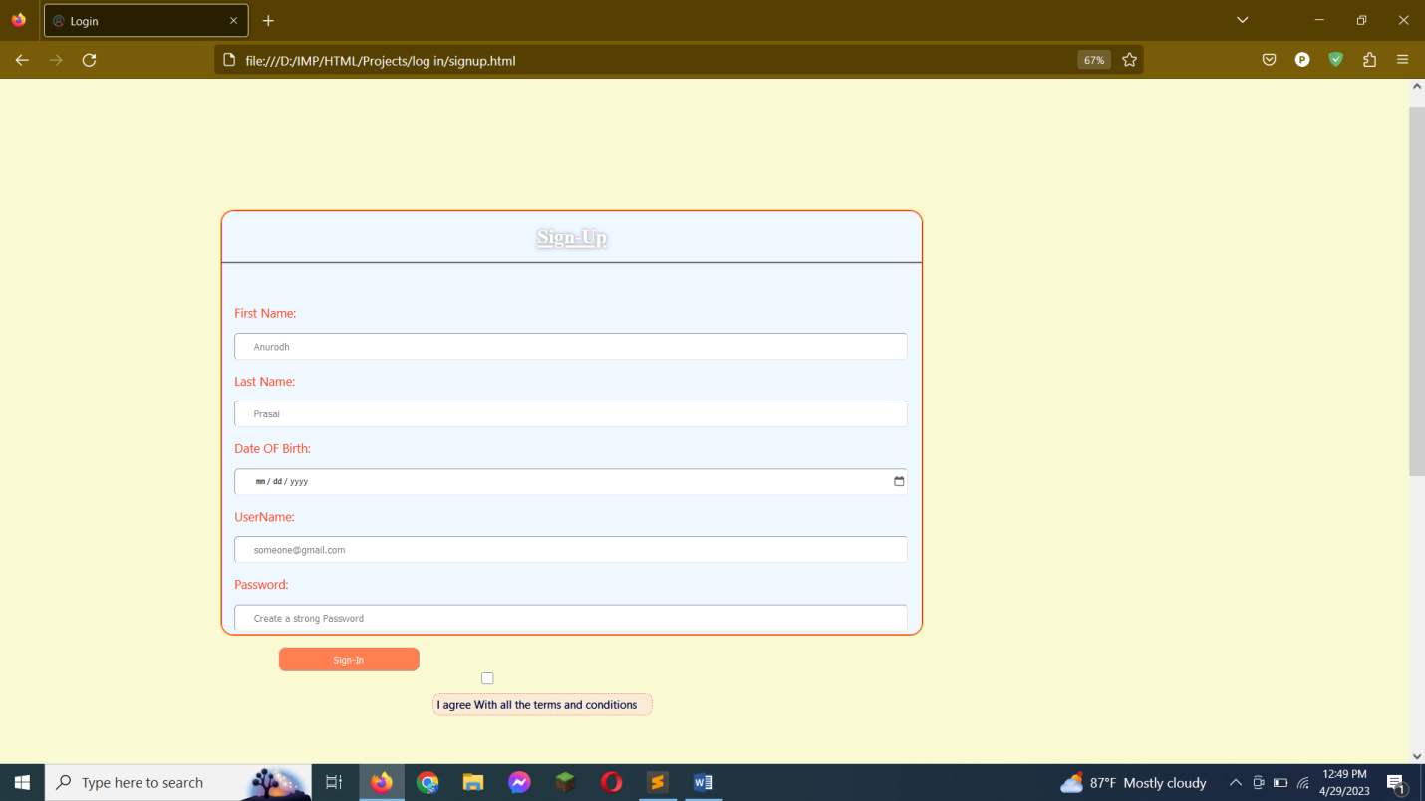

**Fig: Signup Form (Signup.html)**

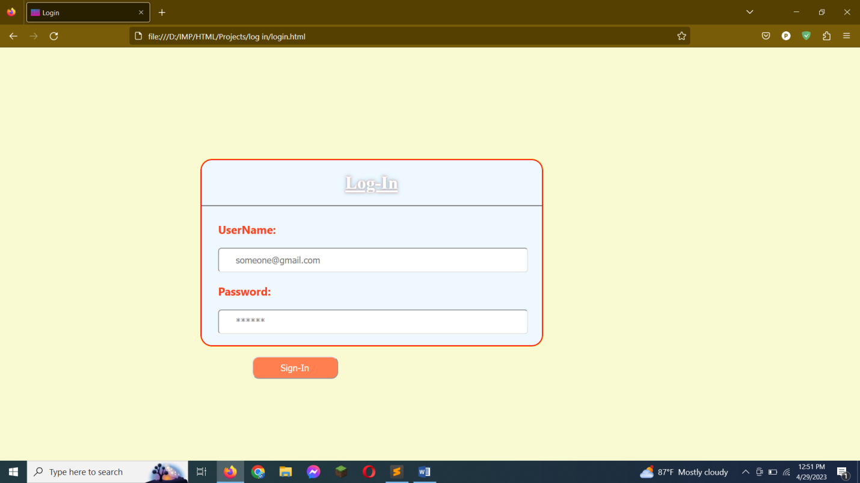

**Fig : Login form (Login.html)**

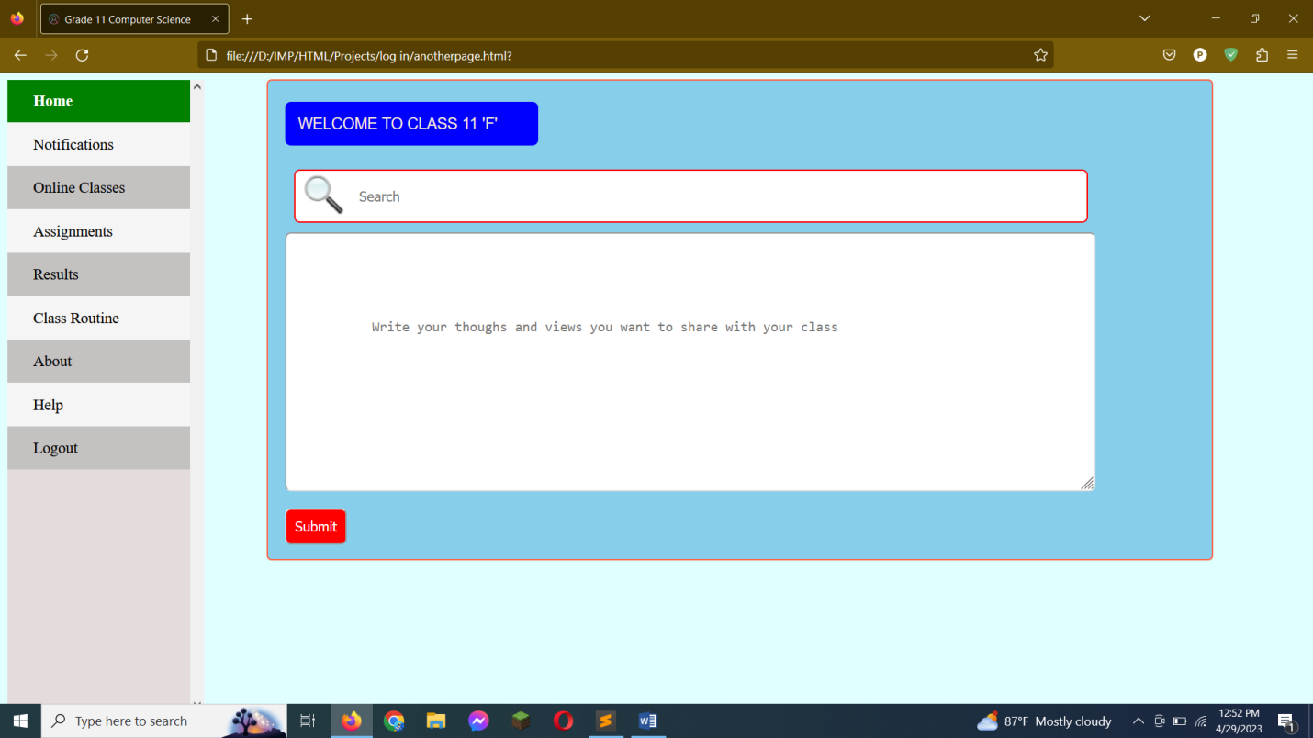

**Fig : Logged in form(anotherpage.html)**

**Conclusion**

In conclusion, the development of an online page or website for online classes and student data is a transformative project that holds immense potential in the field of education. This project offers a multitude of advantages and benefits for students, educators, and institutions alike, revolutionizing the way we approach teaching and learning. One of the key benefits of an online platform for online classes is the flexibility and accessibility it provides to students. By breaking down the barriers of time and location, students can access their courses and educational materials from anywhere and at any time. This convenience is especially beneficial for individuals with busy schedules or those who may have geographical limitations. In addition, online classes offer a diverse range of courses that may not be available in traditional classroom settings. This allows students to explore their interests and passions in a more personalized way. Furthermore, online classes often utilize interactive technologies and multimedia resources to enhance the learning experience. This can include virtual simulations, video lectures, and collaborative group projects. These tools not only engage students but also promote critical thinking and problem-solving skills. Another advantage of online classes is the opportunity for students to develop self-discipline and time management skills. Without the structure of a traditional classroom, students must take responsibility for their own learning and stay on top of assignments and deadlines. This can translate into valuable skills for the workforce, where self-motivation and time management are highly valued. Finally, online classes can also be more cost-effective than traditional classroom settings. With no need for physical classrooms or materials, institutions can offer courses at a lower cost to students. Additionally, online classes eliminate the need for commuting or relocating, which can It enables a more inclusive and equitable learning environment, ensuring that education is accessible to a wider range of learners. Moreover, the integration of student data management within the online platform empowers educators with valuable insights to personalize instruction and track student progress effectively. By harnessing the power of data analytics and visualization tools, teachers can gain a comprehensive understanding of their students' learning patterns, strengths, and areas that require improvement. This data-driven approach allows educators to tailor their teaching methods and provide targeted support to individual students, optimizing their learning experience and facilitating better academic outcomes. In addition to personalized instruction, the online platform facilitates effective communication and collaboration between students and educators. Features such as discussion forums, chat functions, and virtual classrooms enable students to actively engage in peer-to-peer learning, ask questions, and seek clarifications. This interactive and collaborative environment fosters the development of critical thinking, problem-solving skills, and teamwork. Students can learn from their peers, share ideas, and engage in meaningful discussions, enhancing their overall learning experience and promoting a sense of community. Furthermore, the online platform promotes self-paced learning, allowing students to progress through the material at their own speed. Each student has a unique learning style and pace, and traditional classroom settings may not always accommodate these individual needs. With the online platform, students have the freedom to revisit concepts, access supplementary materials, and engage in additional practice exercises as needed. This personalized approach ensures a deeper understanding of the subject matter and allows students to focus on areas that require more attention. Self-paced learning empowers students to take ownership of their education, fostering independence, self-discipline, and a lifelong love for learning. Another significant advantage of an online page or website for online classes is the availability of a diverse range of resources. In addition to the core course materials, students can access multimedia content, interactive quizzes, and supplementary readings. These resources provide multiple avenues for learning, catering to different learning styles and preferences. Visual learners can benefit from engaging videos and infographics, while auditory learners can access recorded lectures and podcasts. The availability of a variety of resources ensures that students can explore and comprehend the subject matter from different angles, enhancing their overall learning experience. Additionally, the implementation of an online platform streamlines administrative tasks and optimizes the workflow for educators. Student data management systems within the online platform enable seamless tracking of student attendance, assignments, and grades. This automation reduces the administrative burden on educators, allowing them to focus more on instructional activities and student engagement. Furthermore, the online platform provides a centralized hub for sharing important announcements, course materials, and deadlines, ensuring clear and efficient communication between educators and students. It is essential to acknowledge the importance of data security and privacy in the implementation of an online platform. Institutions must prioritize the protection of student data and adhere to strict security protocols. By implementing robust security measures and following industry standards, the online platform can ensure the confidentiality and integrity of student information, fostering trust and confidence among students and parents. In conclusion, the development of an online page or website for online classes and student data represents a significant advancement in the field of education. By leveraging technology, this project revolutionizes the way we learn and teach, offering flexibility, personalization, and collaboration. Moreover, the online platform provides an opportunity for students to access educational resources from anywhere and at any time, making learning more accessible and convenient. This innovation also allows teachers to create interactive and engaging lessons that cater to the individual needs of each student. Additionally, the use of technology in education enhances communication between teachers, students, and parents, promoting transparency and accountability. With this online system, parents can easily monitor their child's progress and stay informed about their academic performance. Overall, the implementation of an online page or website for education promotes a more inclusive and dynamic learning environment that fosters trust and confidence among students and parents alike.